➢➢ Explanation :
- Consider that a byte is present at the memory location D000 H and second byte is present at memory location D001 H.
- We have to multiply the bytes present at the above two memory locations.
- We will multiply the numbers using successive addition method.
- In successive addition method, one number is accepted and other number is taken as a counter. The first number is added with itself, till the counter decrements to zero.
- Result is stored at memory locations E000 H and E001 H.
For example : D000 H = 12 H, D001 H = 10 H
Result = 12H + 12H + 12H + 12H + 12H + 12H + 12H + 12H + 12H + 12H
Result = 0120 H
E000 H = 20 H
E001 H = 01 H
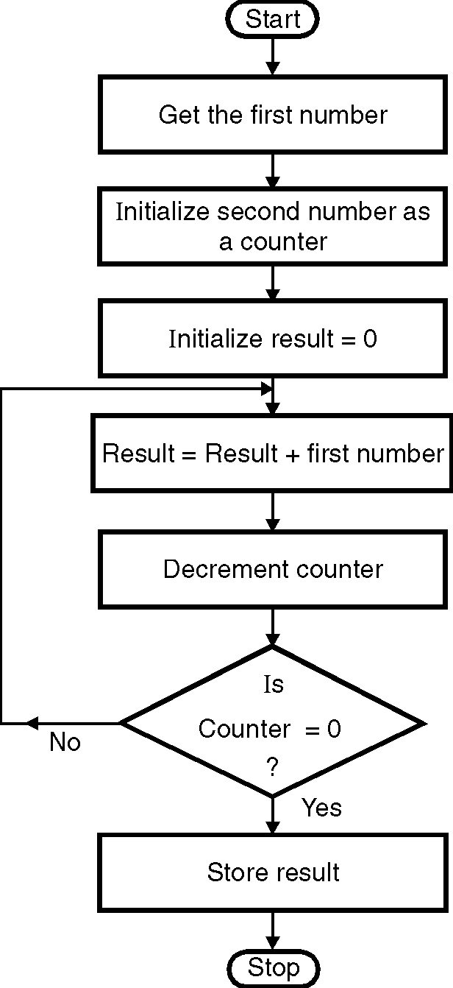
➢➢ Algorithm :
Step I : Get the first number.
Step II : Get the second number as counter.
Step III : Initialize result = 0.
Step IV : Result = Result + First number.
Step V : Decrement counter
Step VI : If count ≠ 0, go to step V.
Step VII : Store the result.
Step VIII : Stop.
➢➢ Flowchart : Refer flowchart 19.
➢➢ Program :
Instruction Comment
LDA D000H ; A = first number
MOV E, A ; E = first number
MVI D, 00 ; D = 00 H
LDA D001H ; A = second number
MOV C, A ; Initialize counter
LXI H, 0000H ; Result = 0
BACK: DAD D ; Result = result + first number
DCR C ; decrement count
JNZ BACK ; If count 0 repeat
SHLD E000H ; Store result
HLT ; Terminate program execution Flowchart 19

